Conference in Serbia:
Call for Papers: –
Deadline for submission 24th January 2015.
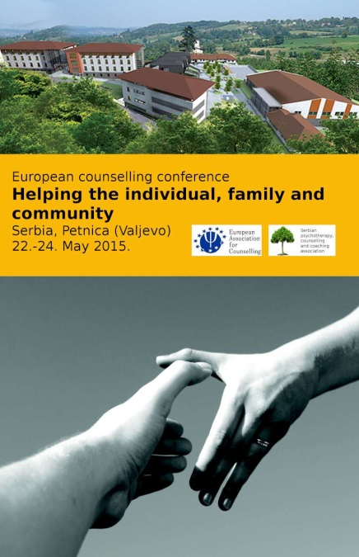
Interested – email info@eac.eu.com now to register your interest.

